Expense

PAS allows the project team members to key in expenses incurred for pre-defined categories of project related and non-project related.

Generally PAS Expense Claim procedures (diagram 1) includes four steps which are
- Expense Entry
- Expense Verify
- Expense Approval
- Expense Pay-Out

For some expenses are not included in expense claiming such as Airfare Expense, housing Expense and Other Expense, the specified Project Assistant will maintain them into the system in following functions
- Other Cost Entry
- Airfare Cost Entry
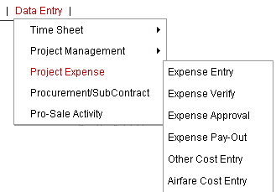
Diagram 1: Expense

The general idea for expense claim working flow (diagram 2) is shown as following:
Staff keys in and submit the expense
Staff asks PM to approve the expense online
PM approves the expense online
Staff prints out expense form, attach invoices and submit to PA
PA verifies the amount and submits to manager
Manager signs on paper and passes to PA
PA updates online status and post to F&A
F&A verifies the amount and pay out
F&A updates online status and transfer data into SUN system

Diagram 2: Expense Claim working flow
Expense Entry

Project team members may key in the expenses for selected project in this section (diagram 3).
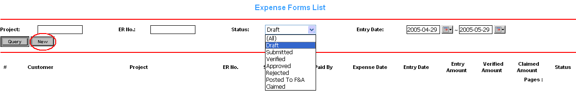
Diagram 3: Expense entry (1)

User may create a new expense form by clicking “New” button. Unlike traditional procedures, user now may trace all the expenses status after submitting by choosing different status.
- Draft: user has saved the expense form as draft. User can change draft expense at any time.
- Submitted: user has submitted the expense form and ready to be approved online.
- Verified: PA has verified the amount for submitted expense form (Not Applicable for Shanghai).
- Approved: PM has approved project members’ expense forms, which cannot be modified again by members.
- Rejected: PM has rejected project members’ expense forms, which staff needs to confirm and re-submit again.
- Post To F&A: PA has posted the expense forms to Finance which are approved and signed by managers.
- Claimed: Finance staff has paid out the expense forms.

PAS will ask user to select a desired project first, specify the expense time period, specify the currency and identify the entering expense is paid by customer or company (diagram 4).

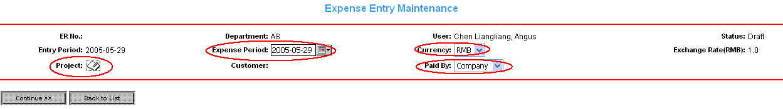
Diagram 4: Expense entry (2)

“Expense time period” is normally when your expense occurred and “currency” will tell the different rate. It is very necessary for user to identify the entering expense is paid by customer or company, because it will tells the system this expense is going to be a billing or payment. If you are not sure with paid by whom, please ask project manager. If you have two expenses for the particular week and one is paid by customer, the other is paid by company, please create two different expense forms.
As mentioned, user has to select a desired project to key in the expense (diagram 5).
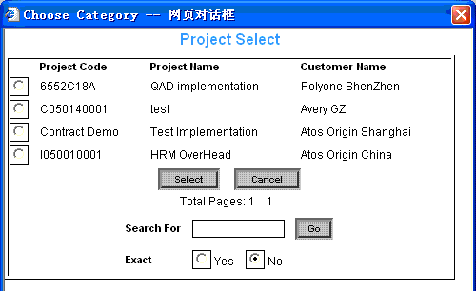
Diagram 5: Expense entry (3) project selection

If the desired project is not available for you to choose, please confirm with project manager.

Important Notes:
- We have built some internal projects called “General Expense Claim” for each of department in Shanghai. Those projects are always available for staffs to select to key in the non-project related expense like fixed month telephone expense.

After correctly selecting a project and other conditions, user is able to key in the expense (diagram 6).
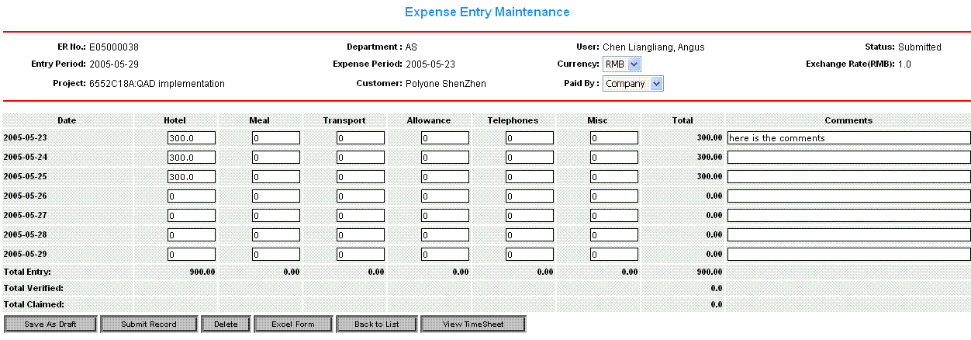
Diagram 6: Expense entry (4) expense detail entry

All categories of expense are defined as six types, which are “Hotel”, “Meal”, ”Transport”, “Allowance”, “Telephone” and “Misc”. “Misc” refers to “others”. It is staff’s responsibilities to fill the expense correctly based on these types.

Important Notes:
- “Allowance” category only appears when paid by company.
- Allowance Claim must be filled in a separated form if you have other expenses to claim in the same week.
- If you work on a contract project for entire week, you need to key in entire weekday’s allowance.
- For Allowance Claim, you must provide the correct amount of invoices attached and CAF with correct date same as allowance date.
- For the weekend, if you cannot have CAF from customer, please ask you project manager to sign a CAF for you to claim allowance.
- For the Fixed Price project, if you cannot have CAF from customer, please ask you project manager to sign a CAF for you to claim allowance.
- For other expense claiming excluding allowance, just provide the correct amount of invoices attached.

User is also able to input the expense description in “comments” boxes. After correctly entry, user may save it as draft, submit it to be ready for approval, delete it, export it to Excel file or view the time sheet stats by clicking corresponding buttons.

It is staff’s responsibility to tell PM that you have expenses ready to be approved.
If the expense is being approved by the project manager, user is not allow to modify this expense any more (diagram7).

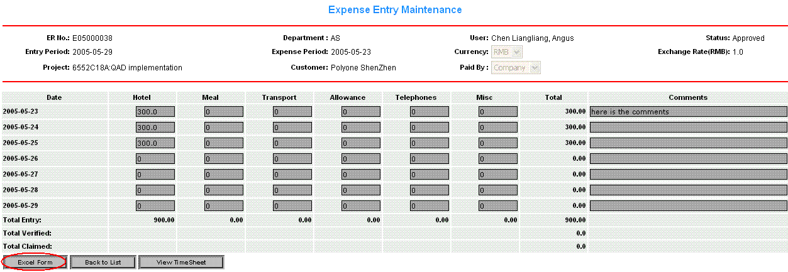
Diagram 7: Approved Expense

Now user needs to export it to Excel Form by clicking the “Excel Form” button, print it out and attach the invoices. This is going to be submitted to PA instead of red pager, and ready for managers to check and signed.

If the expense is being rejected by the project manager, user needs to confirm with PM and re-submit this expense (diagram8).

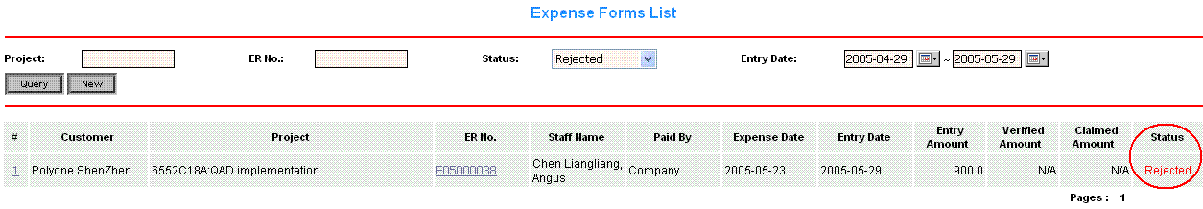
Diagram 8: Rejected Expense

Expense Verify

Generally two operations will be implemented by project assistant in this section.
- Verifying the Expense Forms: Project Assistant needs to verify the expense forms, which submitted by staffs before they are getting approved by project manager. Normally the forms with status “Submitted” need to be verified (Not Applicable for AO Shanghai);
- Posting the Expense Forms to F&A: Project Assistant needs to query the expense forms which approved by project managers, and post them to Finance & Accounting. Normally the forms with status “Approved” need to be posted to F&A.

Verifying the Expense Forms (Not Applicable for AO Shanghai)

Once user submits the expense form, it needs to be verified by Project Assistant or who else related to make it ready for project manager to approve later (diagram 9).
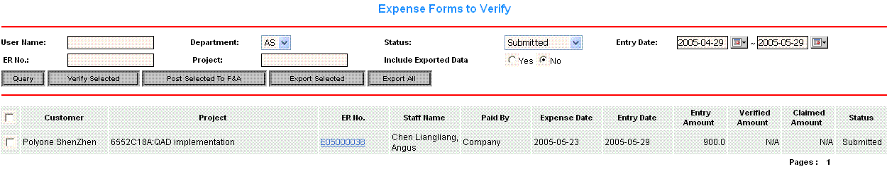
Diagram 9: verify expense (1)
Project assistant may verify the specific expense form by tick the check box corresponding with the specified expense form and click “Verify Selected” button. Project assistant may export the specific expense to Excel file by tick the check box corresponding with the specified expense form and click “Export Selected” button. If PA wants to export all the forms, just click “Export All” button; “Include Exported Data” identifies to show all the forms satisfied with conditions include / exclude those forms which have exported before will show in the list.

PA may view the expense details by clicking the “ER No.”(diagram 10).
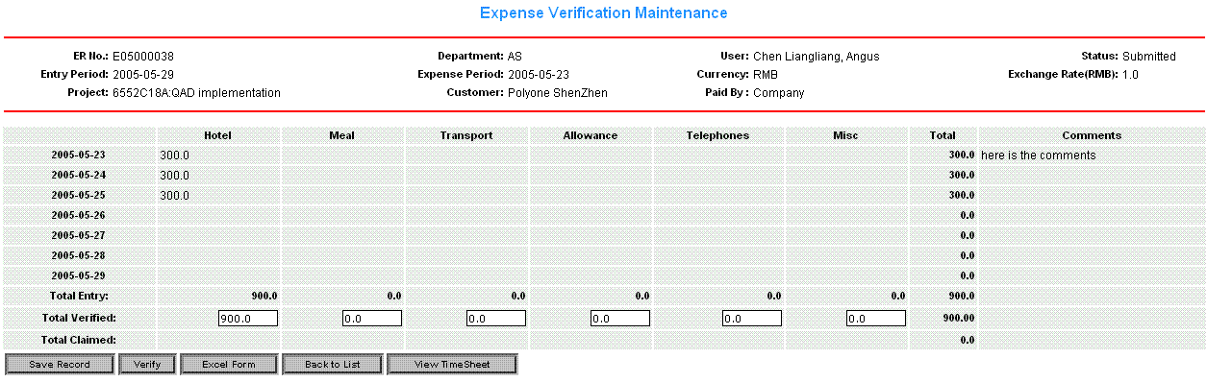
Diagram 10: verify expense (2)
PA may modify the figures in the text box corresponding with the “Total Verified” row, and is allowed to save, verify, export it to Excel file or view the time sheet stats by clicking corresponding buttons.
Posting the Expense Forms to F&A

Once the expense forms have been approved by project managers, the project assistant can query these approved forms with selecting the “Approved” status (diagram d11).
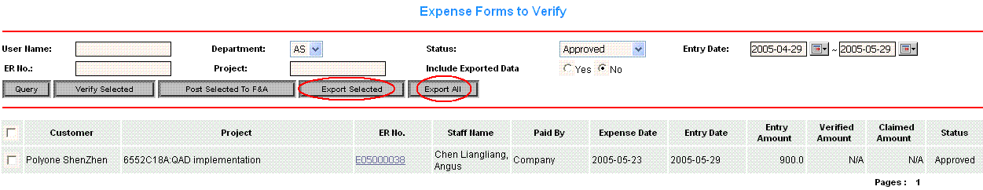
Diagram 11: post to F&A (1)

Project assistant may post the approved expense form to F&A by tick the check box corresponding with the approved expense form and click “Post Selected To F&A” button. PA needs to print out a checklist, in which indicates what expense forms will be posted to F&A every time, by clicking “Export Selected” / “Export All” button.

PA also can view the expense details by clicking the “ER No.” (diagram 12).

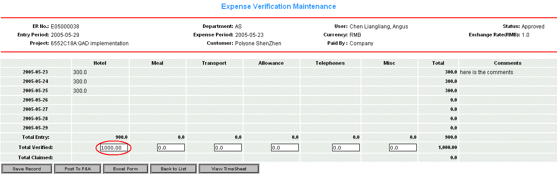
Diagram 12: post to F&A (2)

PA may still modify the figures in the textbox for the “Total Verified” field until this form is getting claimed. If PA wants to post this form to F&A, just click “Post To F&A” button.

Expense Approval

Once the expense forms are ready to be approved, Project Manager in this section is able to check and approve the expense diagram 13.

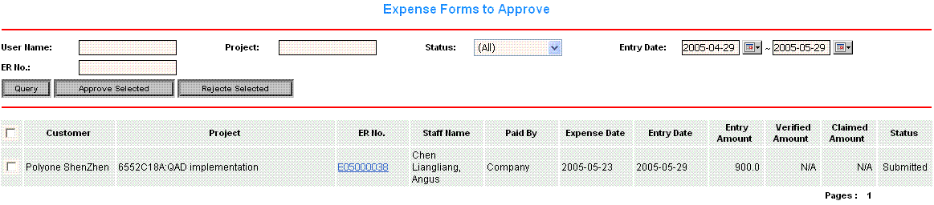
Diagram 13: Expense Approval (1)

Project manager may approve or reject the specific expense form by tick the check box corresponding with the specified expense form and click “Approve Selected” or “Reject Selected” button. If PM wants to approve or reject all the forms, just tick the top check box;

Project Manager may view the expense details by clicking the “ER No.” diagram 14.

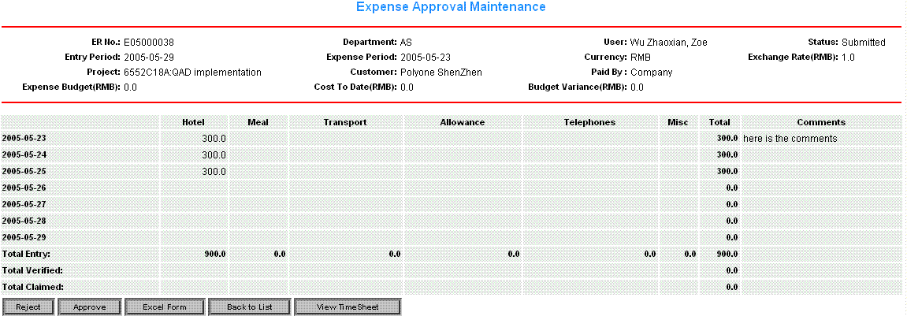
Diagram 14: Expense Approval (2)

Project manager is allowed to
- Approve this expense form by clicking “Approve” button. Once the expense form is approved, it cannot be modified any more;
- Reject this expense form by clicking “Reject” button. Staff need to confirm with PM and re-submit.
- PM may export this form to Excel file by clicking “Excel Form” button;
- If PM wants to go back to the form list (diagram 13), click “Back to List” button;
- If PM wants to check the time sheet records, click “View Timesheet”.

Expense Pay-Out

Once the PA sends all the expense forms which are approved and signed to F&A, now they are ready to be claimed (diagram15).
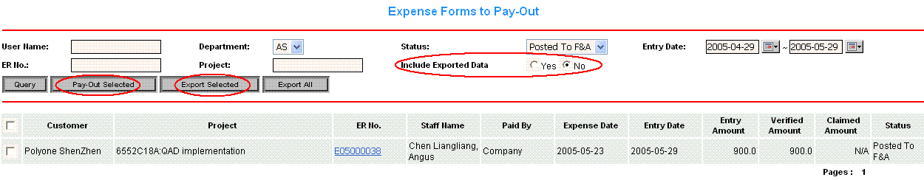
Diagram 15: Expense Pay-out (1)

Finance staff may need to do the following steps to pay out the expense.
- Select status as “Post To F&A”.
- Select “Include Exported Data” as No if you are doing new claiming.
- Tick the checkbox for what are ready to be claimed.
- Click “Export Selected” button to export selected expenses into Excel file.
- Transfer this Excel file into SUN system.
- If all transferring correctly, then click “Pay-out Selected” button to update the expense status to “claimed”

Finance staff may view the expense details by clicking the “ER No.” (diagram 16)
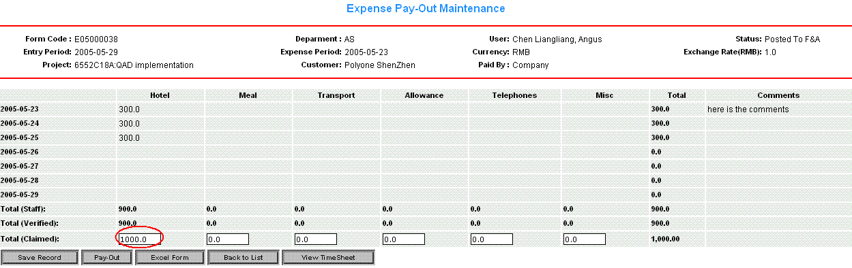
Diagram 16: Expense Pay-out (2)

- Finance staff may modify the figures in the text box corresponding with the “Total (Claimed)” row, and is allowed to save, pay-out, export to Excel, and view this week’ time sheet by clicking corresponding buttons.

